Drop beer board computer

Open Plotter 2.0 setup guide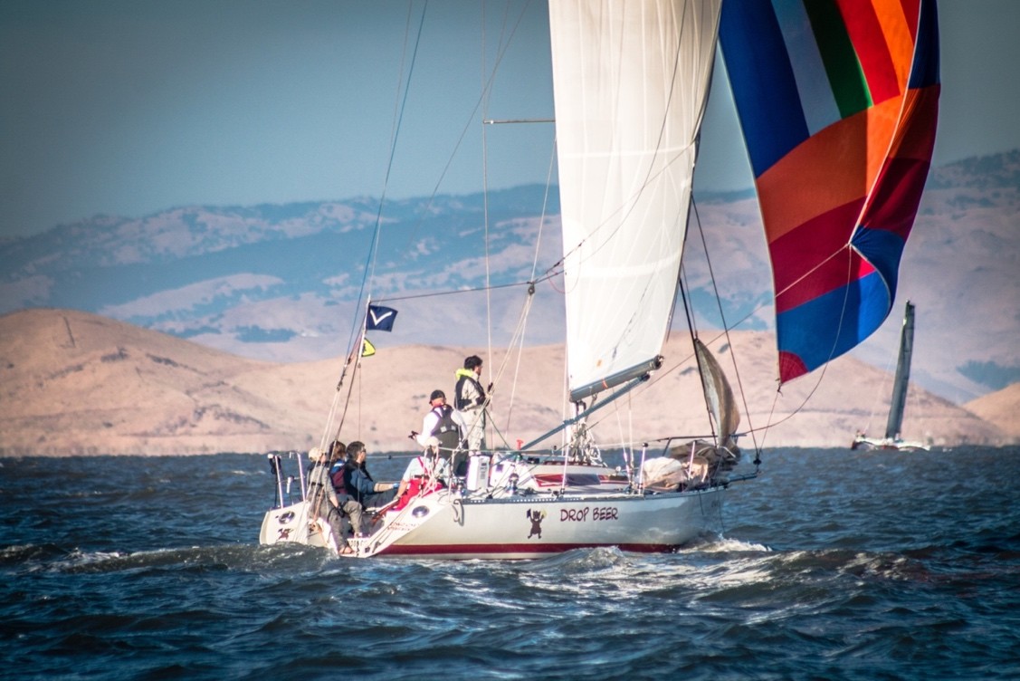

Index

Table of Contents

Basic OP2 setup 4

Setup Artik fan 5

Copy USB stick to local memory 5

Setup networks: local and wide 5

Setup SignalK 6

OpenCPN 7

VNC 7

Gmail 7

Drop Beer node-red 8

Setup influxdb 9

Setup Grafana 9

Mailer 9

Arduino 10

engine_sensor.ino 10

DropBeer.ino (Power Control Unit) 11

Library customizations 12

Adafruit_INA219.h 12

Adafruit_INA219.cpp 12

MD_MAX72XX.h 13

MD_MAX72XX.cpp 13

Backup copy 14

Passwords 14

SignalK setup 15

Installed apps 15

Server/Vessel data 17

Server/Connections + engine_sensor 17

Server/Plugin Config/SKtoNMEA0183 18

Server/Plugin Config/SKtoNMEA2000 21

Server/Plugin Config/Derived-data 29

Server/Plugin Config/UDP NMEA0183 Sender 32

Server/Plugin Config/InfluxDB 33

Connections 35

OpenCPN 35

GPS 35

## Basic Drop Beer setup

1. Arduino Nano as Drop Beer Board Computer control station
2. Install RPi imager on desktop
   1. <https://www.raspberrypi.org/downloads/>
   2. <https://www.raspberrypi.org/blog/raspberry-pi-imager-imaging-utility/>
3. Install non-NOOBS Raspberry Pi OS (32 bit) with desktop in an SD card
   1. <https://www.raspberrypi.org/downloads/raspberry-pi-os/>
4. Boot RPi
5. Copy SD card onto SSD card
6. Enable RPi to boot from SSD
7. In RPi config
   1. Change RPi password
   2. Hostname = DropBeer
   3. Set location/locale=english/us/ISO-8859
   4. Set timezone=america/los angelos
   5. Set keyboard=generic 105/english-us/english-us
   6. Set wifi=us
   7. Enable I2C
   8. Enable VNC

## OpenPlotter 2

1. Install OpenPlotter2
   1. <https://github.com/openplotter/openplotter-settings/releases>
   2. Rename menu item “Other” to “OpenPlotter”
2. Update RPi
   1. *sudo apt-get update*
   2. *sudo apt-get full-upgrade*
3. Install all OP2 packages, *except*
   1. Moitessier hat
   2. Kplex
   3. SDR VHF

## OpenCPN

1. Install OpenCPN
2. Open OpenCPN
3. Download maps
4. Prepare all charts
5. Load local race markers in separate layer
   1. Site: <https://www.sequoiayc.org/sycracingmarkers>
   2. File: <https://www.sequoiayc.org/sites/default/files/SeqYC%20Racing%20Marks%202019-05.gpx_.txt>

## SignalK

1. Install SignalK
2. Enable security by adding user/password
3. Install SignalK plugins:
   1. @signalk/udp-nmea-plugin
      1. BroadcastAddress=10.10.10.255
   2. Nmea0183-to-nmea0183-plugin
   3. Signalk-cloud
      1. Obtain key from web site
   4. signalk-raspberrypi-monitoring
   5. signalk-tide-watch or signalk-tides-api
   6. signalk-to-nmea2000
   7. Signalk-wilhelmsk-plugin
      1. Enable
   8. @signalk/signal-node-red
   9. signal-alarm-silencer
   10. signal-notification-acker
   11. influxdb
   12. optional: sksim
4. Restart signalk

## Dashboards

1. Install Dashboards
   1. Influxdb/Grafana
   2. Node-red dashboard (optional)

## Setup networks: local and wide

1. Configure OP2: Network
   1. AP and station (rpi3)
   2. Sharing: auto
   3. SSID: “GoFree-5670”
   4. Password
2. Reboot

## Serial

## Can Bus

## PyPilot

## Setup UI panels

1. Add panel applet
   1. CPU Temperature Monitor
   2. CPU Usage Monitor
2. Setup applets as desired

## Install Drop Beer specifics

* 1. Insert prepared USB stick in RPi
  2. On Rpi change directory into USB stick folder
  3. Run ‘setup_dropbeer.sh’; this installs
     1. Power control interface
     2. LCD screen configuration
     3. Wifi stay alive
     4. Artik fan controls
     5. Arduino development environment
     6. ….

## Setup Artik fan

1. Artik fan specific setup
   1. 40o: 20%
   2. 45o: 40%
   3. 50o: 60%
   4. 55o: 100%

## Setup SignalK

1. Configure OP2: SignalK
   1. Vessel data
2. Configure OP2: Server plugins
   1. Convert SignalK to NMEA0183
      1. Enable
      2. Enable pretty much everything
   2. Convert SignalK to NMEA2000
   3. Edit zones ???
   4. Set system time
3. Add signal sources
   1. Engine_sensor
      1. Server/connection/port:55557

## VNC

1. RPI config: enable VNC
2. Make virtual screen larger
   1. xrandr -s 1280x720

## Gmail

Setup GMAIL

Open browser

Setup user: dropbeerboardcomputer@gmail.com

Password: …

## Drop Beer node-red

1. Add “e-mail” palette
2. Import flow by cut/paste from filevault
   1. Drop Beer node-red function
   2. Derive depth below keel
   3. Derive depth below surface
   4. Check MAIN and HOUSE batteries every 24 hours
   5. Check MAIN and HOUSE batteries for reaching 12 volts, email warning if so
   6. Setup emailer
      1. Open each email node, add < from email> and <from password>, redeploy. Check the messages pass
   7. 
   8. 
   9. 

## Setup influxdb

Assign database name: “dropbeerdb”

## Setup Grafana

Assure that when opening the database “dropbeerdb”, that i.s.o. “localhost” it references “127.0.0.1”. Otherwise it appears to work, but the database is empty.

## Mailer

Not needed/working for GRIB file exchange, use the “XyGrib GRIB file viewer” for that purpose

## Mpstat

Check

<http://localhost:3000/admin/#/serverConfiguration/log>

for message “sudo: mpstat: command not found”

See <https://github.com/sysstat/sysstat> for installation instructions

## Actisense

1. Need to scan all required actisense pass codes in signalk plugin for NMEA2000
   1. Update actisense using NMEAReader to allow these codes to pass
2. Was not playing nicely with OP2. Burst mode, causing inconsistent data updates and overall very slow.
   1. Firmware upgrade of the actisense (from 2016 to recent) solved this.

## Arduino

### engine_sensor.ino

Add ESP8266 libraries:

<https://dl.espressif.com/dl/package_esp32_index.json> , <http://arduino.esp8266.com/stable/package_esp8266com_index.json>



Arduino IDE Parameters:

* #ide_param:board=NodeMCU 1.0 (ESP-12E Module)

*

* Use compile, then export compiled library to local file location

* Find engine_sensor node using "sudo nmap –sn 10.10.10.1/24"

* This will show the engine_sensor node at 10.10.10.101, assuming the

* static IP address has not been modified

* Upload compiled sketch to: <http://10.10.10.101:8080/webota>

1. Copy all files from usb stick to ~/arduino
2. Compile/upload both nodes (wired)
3. Later, for updates, in order to find engine_sensor ip address
   1. sudo apt-get install nmap
   2. sudo nmap –sn 10.10.10.1/24

### DropBeer.ino (Power Control Unit)

/* Manually set the correct IDE parameters...

*

* Arduino IDE Parameters:

* #ide_param:board=Arduino Nano

* #ide_param:processor=ATmega328P

* #ide_param:port=ttyUSB1 (or whatever ttyOP_ard points to)

*/

## Library customizations

### Adafruit_INA219.h

|  |
| --- |
| /**************************************************************************/  /*!  @brief Class that stores state and functions for interacting with INA219 current/power monitor IC  */  /**************************************************************************/  class Adafruit_INA219{  public:  Adafruit_INA219(uint8_t addr = INA219_ADDRESS);  void begin(void);  void begin(TwoWire *theWire);  void setCalibration_32V_2A(void);  void setCalibration_32V_1A(void);  void setCalibration_16V_400mA(void);  void setCalibration_16V_160A(void);  float getBusVoltage_V(void);  float getShuntVoltage_mV(void);  float getCurrent_mA(void);  float getPower_mW(void); |

### Adafruit_INA219.cpp

|  |
| --- |
| /**************************************************************************/  /*!  @brief Configures to INA219 to be able to measure up to 16V and 160A  of current.    @note These calculations assume a 0.00075 ohm resistor is present  */  /**************************************************************************/  void Adafruit_INA219::setCalibration_16V_160A(void) {    ina219_calValue = 32768;  ina219_currentDivider_mA = 320; // Current LSB = 50uA per bit (1000/50 = 20)  ina219_powerMultiplier_mW = 0.10f; // Power LSB = 1mW per bit    wireWriteRegister(INA219_REG_CALIBRATION, ina219_calValue);    uint16_t config = INA219_CONFIG_BVOLTAGERANGE_16V |  INA219_CONFIG_GAIN_1_40MV |  INA219_CONFIG_BADCRES_12BIT |  INA219_CONFIG_SADCRES_12BIT_1S_532US |  INA219_CONFIG_MODE_SANDBVOLT_CONTINUOUS;  wireWriteRegister(INA219_REG_CONFIG, config);  } |

### MD_MAX72XX.h

|  |
| --- |
| class MD_MAX72XX  {  public:  /**  * Module Type enumerated type.  *  * This enumerated type is used to defined the type of  * modules being used in the application. The types of modules are  * discussed in detail in the Hardware section of this documentation.  */  enum moduleType_t  {  PAROLA_HW, ///< Use the Parola style hardware modules.  GENERIC_HW, ///< Use 'generic' style hardware modules commonly available.  ICSTATION_HW, ///< Use ICStation style hardware module.  FC16_HW, ///< Use FC-16 style hardware module.  DB_HW // what I actually have  }; |

### MD_MAX72XX.cpp

Seems I can just use ICSTATION, no need for customization.

|  |
| --- |
| void MD_MAX72XX::setModuleParameters(moduleType_t mod)  // Combinations not listed here have probably not been tested and may  // not operate correctly.  {  _mod = mod;  switch (_mod)  {  case PAROLA_HW: _hwDigRows = true; _hwRevCols = true; _hwRevRows = false; break; // tested MC 8 March 2014  case GENERIC_HW: _hwDigRows = false; _hwRevCols = true; _hwRevRows = false; break; // tested MC 9 March 2014  case ICSTATION_HW: _hwDigRows = true; _hwRevCols = true; _hwRevRows = true; break; // tested MC 9 March 2014  case FC16_HW: _hwDigRows = true; _hwRevCols = false; _hwRevRows = false; break; // tested MC 23 Feb 2015  case DB_HW: _hwDigRows = true; _hwRevCols = true; _hwRevRows = true; break; // what I actually have  default: _hwDigRows = _hwRevRows = _hwRevCols = false; break; // not a known board config  }  } |

## Backup copy

Use USB stick with SD card option

Run Accessories/SD Card Copier

## Passwords

|  |  |  |
| --- | --- | --- |
| Application | Username | Password |
| Raspberry pi | pi | degroeten |
| signalk | Drop Beer | degroeten |
| Grafana | admin | degroeten |
| SignalK cloud token |  |  |
| VNC | beercansailor@gmail.com |  |
| WiFi to shore |  |  |

## SignalK setup

### Installed apps

../../../../../../../Users/hans/Desktop/Signal%20K%20Node%20S

### Server/Vessel data

### Server/Connections + engine_sensor

### Server/Plugin Config/SKtoNMEA0183

../../../../../../../Users/hans/Desktop/Signal%20K%20Node%2



### Server/Plugin Config/SKtoNMEA2000



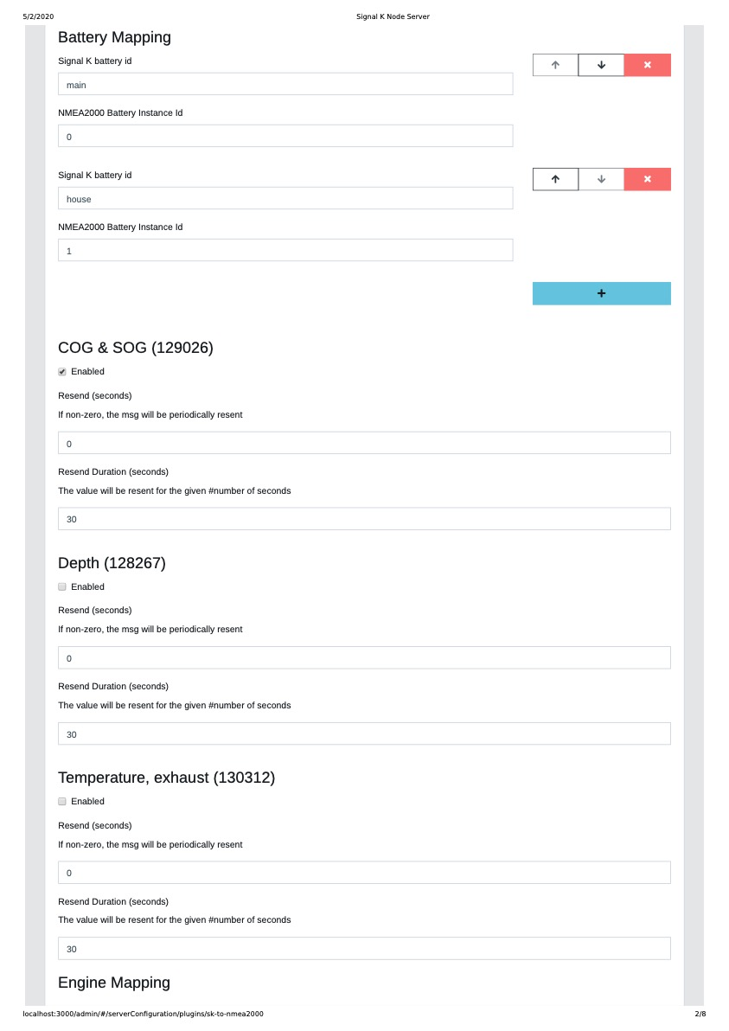











### Server/Plugin Config/Derived-data





### Server/Plugin Config/UDP NMEA0183 Sender

### Server/Plugin Config/InfluxDB



## Connections

### OpenCPN



### GPS

Adapt to 38kbaud



## Running Raspbian from USB Devices : Made Easy

This allows to boot from SD, and run from USB. Thus improving reliability of the system.

<https://www.raspberrypi.org/forums/viewtopic.php?t=196778>